Chapter 1
Overview of Marketing

Tools For Instructors

- Brief Chapter Outline
- Learning Objectives
- Chapter Overview (“Summing Up”)
- Extended Chapter Outline with Teaching Tips
- PowerPoint Slides with Teaching Notes
- Answers to End of Chapter Learning Aids
- Chapter Case Study
- Additional Teaching Tips

Brief Chapter Outline

What is Marketing?
Why is Marketing Important?
Summing Up
End of Chapter Learning Aids
Chapter Case Study: A Starbucks Juggernaut

Learning Objectives

LO1 Define the role of marketing in organizations.
LO2 Describe how marketers create value for a product or service.
LO3 Understand why marketing is important, both within and outside the firm.

Chapter Overview (“Summing Up”)

LO1 Define the role of marketing in organizations.

Marketing is the activity, set of institutions, and processes for creating, capturing, communicating, delivering, and exchanging offerings that have value for customers, clients, partners, and society at large. Marketing strives to create value in many ways. If marketers are to succeed, their customers must believe that the firm’s products and services are valuable; that is, they are worth more to the customers than they cost. Another important and closely related marketing role is to capture value of a product or service based on potential buyers’ beliefs about its value. Marketers also enhance the value of products and services through various forms of communication, such as advertising and personal selling. Through communications, marketers educate and inform customers about the benefits of their products and services and thereby increase their perceived value. Marketers facilitate the delivery of value by making sure the right products and services are available when, where, and in the quantities their customers want. Better marketers are not concerned about just one transaction with their customers. They recognize the value of loyal customers and strive to develop long-term relationships with them.

LO2 Describe how marketers create value for a product or service.

Value represents the relationship of benefits to costs. Firms can improve their value by increasing benefits, reducing costs, or both. The best firms integrate a value orientation into everything they do. If an activity doesn’t increase benefits or reduce costs, it probably shouldn’t occur. Firms become value driven by finding out as much as they can about their customers and those customers’ needs and wants. They share this information with their partners, both up and down the supply chain, so the entire chain collectively can focus on the customer. The key to true value-based marketing is the ability to design products and services that achieve precisely the right balance between benefits and costs. Value based marketers aren’t necessarily worried about how much money they will make on the next sale. Instead, they are concerned with developing a lasting relationship with their customers so those customers return again and again.

LO3 Understand why marketing is important, both within and outside the firm.

Successful firms integrate marketing throughout their organizations so that marketing activities coordinate with other functional areas such as product design, production, logistics, and human resources, enabling them to get the right product to the right customers at the right time. Marketing helps facilitate the smooth flow of goods through the supply chain, all the way from raw materials to the consumer. From a personal perspective, the marketing function facilitates your buying process and can support your career goals. Marketing also can be important for society through its embrace of solid, ethical business practices. Firms “do the right thing” when they sponsor charitable events, seek to reduce environmental impacts, and avoid unethical practices; such efforts endear the firm to customers. Finally, marketing is a cornerstone of entrepreneurialism. Not only have many great companies been founded by outstanding marketers, but an entrepreneurial spirit pervades the marketing decisions of firms of all sizes.

Extended Chapter Outline With Teaching Tips

What Is Marketing? (PPT Slide 1-5, 6)

Marketing is about satisfying customer needs and wants. (PPT slide 1-7)

Marketing entails an exchange. (PPT slide 1-8)

Marketing requires product, price, place, and promotion decisions. (PPT slide 1-9)

Product: Creating Value (PPT slide 1-10)

Price: Capturing Value (PPT slide 1-11)

Place: Delivering the Value Proposition (PPT slide 1-12)

Promotion: Communicating the Value Proposition (PPT slide 1-13)

Marketing can be performed by both individuals and organizations. (PPT slide 1-15)

Marketing impacts various stakeholders. (PPT slide 1-16)

Marketing helps create value. (PPT slide 1-17)

Production-Oriented Era

Sales-Oriented Era

Market-Oriented Era

Value-Based Marketing Era
Check Yourself: Several questions are offered for students to check their understanding of core concepts. (PPT slide 1-19)
- What is the definition of marketing?
Answer: Marketing is the activity, set of institutions, and processes for creating, capturing, communicating, delivering, and exchanging offerings that have value for customers, clients, partners, and society at large
- Marketing is about satisfying _____ and _____.
Answer: Marketing is about satisfying needs and wants.
- What are the four components of the marketing mix?
Answer: The four components of the marketing mix are product, place, price, and promotion.
- Who can perform marketing?
Answer: Both individuals and organizations can perform marketing as marketing can entail B2C, B2B, and C2C.
- What are the various eras of marketing?
Answer: The eras of marketing include the production era, sales era, market era, and value-based era.

What Is Value-Based Marketing? (PPT Slide 1-20)

How Do Firms Become Value Driven? (PPT slide 1-22)

Sharing Information

Balancing Benefits with Costs

Building Relationships with Customers

Connecting with Customers Using Social and Mobile Media (PPT slide 1-25)
Check Yourself: Several questions are offered for students to check their understanding of core concepts. (PPT slide 1-24)
- Does providing a good value mean selling at a low price?
Answer: Value-based marketing isn’t just about low price; it is also about creating strong products and services.
- How are marketers connecting with customers using social and mobile media?
Answer: Marketers are steadily embracing new technologies, such as social and mobile media, to allow them to connect better with their customers and thereby serve their needs more effectively.

Why Is Marketing Important? (PPT Slide 1-25)

Marketing expands firm’s global presence.

Marketing is pervasive across the supply chain. (PPT slide 1-26)

Marketing enriches society. (PPT slide 1-27)

Marketing can be entrepreneurial. (PPT slide 1-28)
Check Yourself: Several questions are offered for students to check their understanding of core concepts. (PPT slide 1-29)
- List five functions that illustrate the importance of marketing.
Answer: Exhibit 1.6 reveals the factors related to the importance of marketing. These include expanding global presence, stretching throughout the organization, working throughout the supply chain, making life easier, and enriching society.
- A firm doing the right thing emphasizes the importance of marketing to _____.
Answer: A firm doing the right thing emphasizes the importance of marketing to society.

Powerpoint Slides With Teaching Notes

Power Point Slide | Teaching Notes
- Overview of Marketing
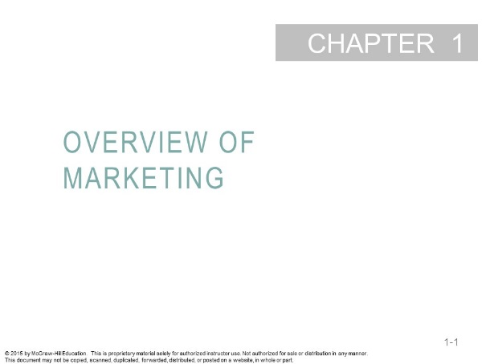
- Learning Objectives  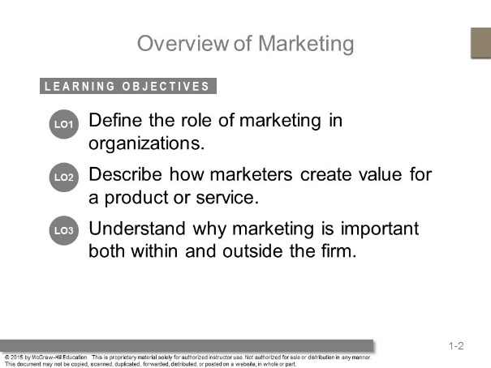 | These questions are the learning objectives guiding the chapter and will be explored in more detail in the following slides.
- Building Value Online  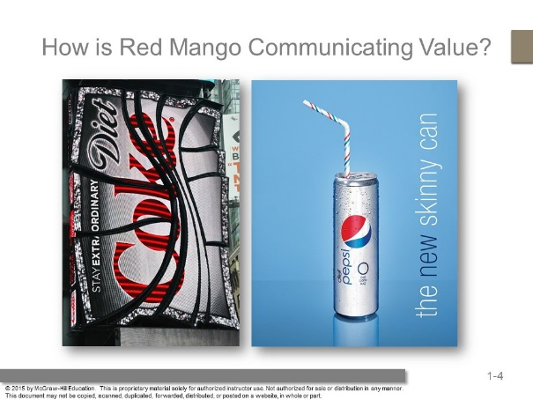 | Ask students: How many of you shop at Starbucks? What do you find most valuable about their products?  Answers will include: It taste great, they are many choices, the company supports green initiatives.  As the text indicates, there are many ways Starbucks distinguishes itself from similar companies.
- What is Marketing?  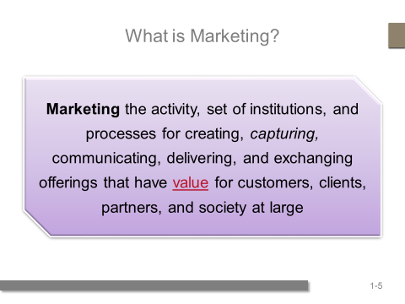 | Point out that this new definition is somewhat controversial, because many feel it includes everything within marketing.  Ask students: Do you agree? Answers might include uncertainly in the definition of value.
- What is Marketing?  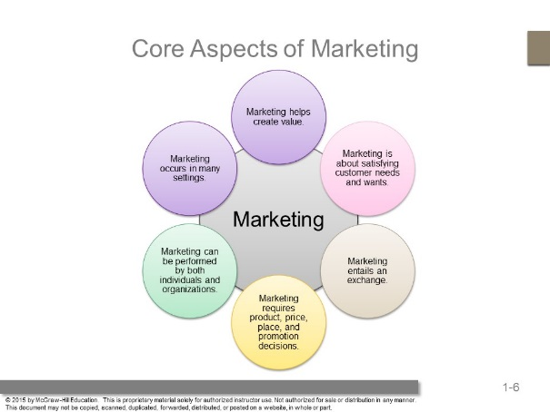 | Ask students about problems they have for which there are no products to meet their needs.  They might think about products that they could use for their homes, their computers, organizing their work, their cars.  This is how marketers generate ideas for new products – by uncovering consumer needs.
- Marketing is about Satisfying Customer Needs and Wants   | Students might mention groups based on age or gender, but the ad is targeted to those who find style to be an important element.  Other benefits might include the status of the Lexus brand.
- Marketing Entails an Exchange  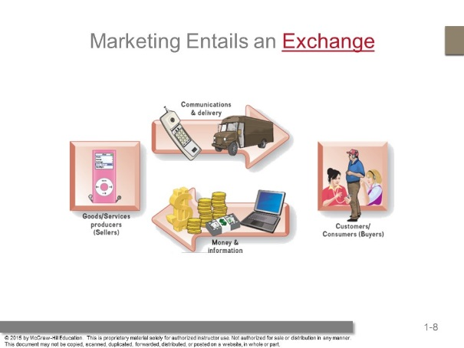 | Each party to the exchange gives up something of value:  The customer usually gives up money; however, sometimes they also give up time and information.  The firm gives up the good or service. The exchange in the end is mutually beneficial.
- Marketing Requires Product, Price, Place and Promotion Decisions  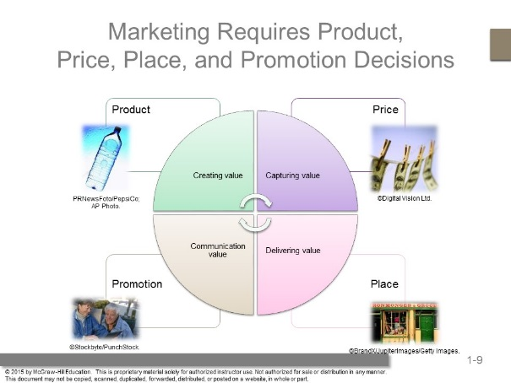 | This is an overview of the 4P’s which will be discussed in greater depth.  Ask students to choose a product they see in the classroom – VitaminWater, Coke, Aquafina – and ask them to describe the 4P’s for this product.
- Product: Creating Value  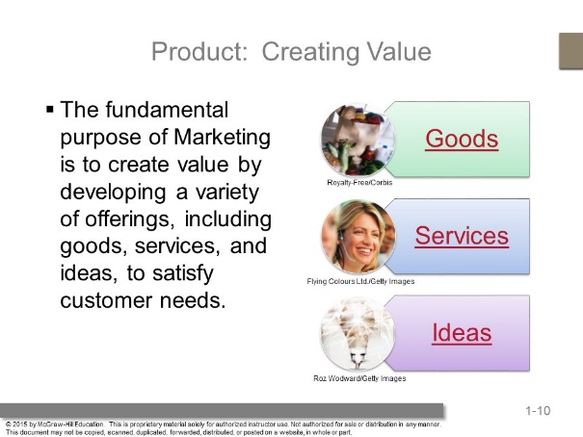 | Students often can relate to goods and services, but the marketing of ideas is a new concept to them. Use the example of drunk driving prevention;  Ask Students: How is that idea marketed?  Organizations such as Mothers Against Drunk Driving or Students Against Drunk Driving often receive support from brewers and distillers in promoting responsible drinking and safe driving.  Ask Students: What is the exchange these groups are asking consumers to enter?  Answer: They want you to consume alcohol in a manner that is consistent with safety, which means sacrificing some consumption.
- Price: Capturing Value  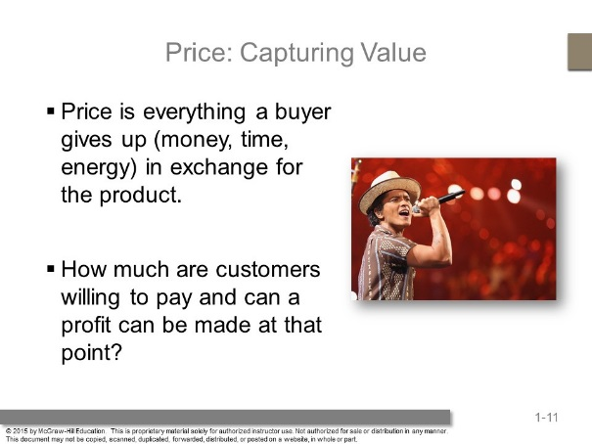 | A good example of how price expresses value is the variations in price associated with air travel.  The prices can vary based on demand for the flight, timing, and destinations.  Pricing strategies will be discussed in later chapters, but you may also wish at this point to introduce the notion of market pricing versus cost pricing.
- Place: Delivering the Value Proposition  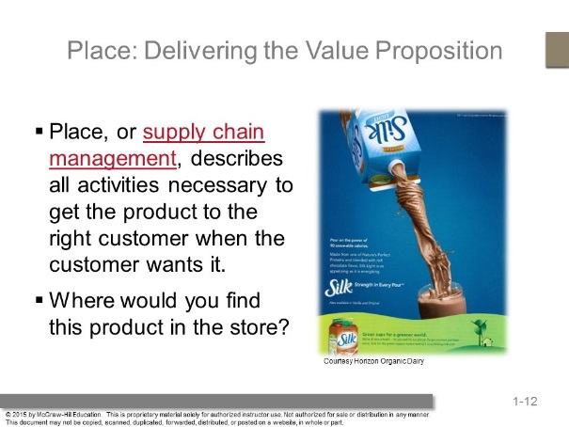 | Place delivers the product to the customers. Students may overlook the importance of this component of the marketing mix because it is not as readily visible from the consumer perspective. To get this point across, suggest a few products and then trace the path those products likely take from manufacturer to retailer to consumer.  It might be hard to see on the ad – but it is interesting to note that Odwalla would want to tell customer’s where to find the product.  Some marketer’s list their distributors if they have limited distribution. It might be difficult to see but on this ad Odwalla tells customers to find this product in the produce section in the circled area.
- Promotion: Communicating Value  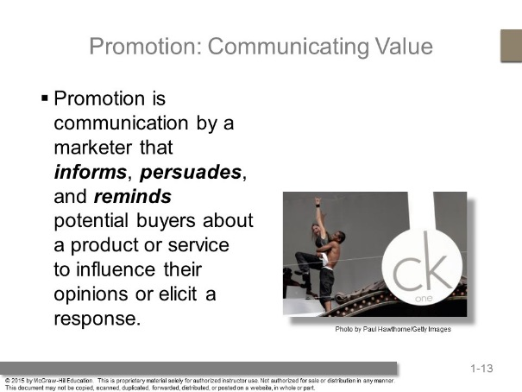 | Calvin Klein’s provocative advertising has helped create an image that is filled with youth, style, and sex appeal.
- What Element of Marketing is This?  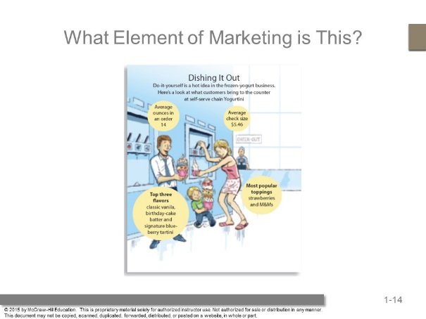 | Ask students what element of marketing is represented in this picture?  Students should recognize that this represents “Place: Delivering the Value Proposition. “ This ad focuses on a type of distribution outlet: self-serve frozen-yogurt. .
- Marketing Can be Performed by Individuals and Organizations  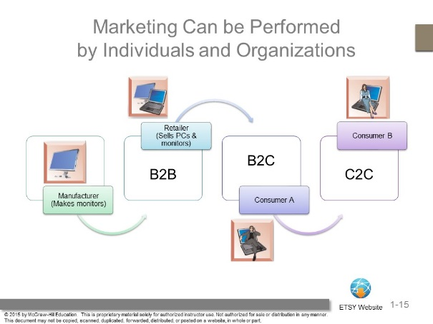 | This exhibit illustrates how the same product, a desktop computer, can be sold from firm to firm, from firm to consumer, and then be used consumer to consumer to sell C2C.  Ask students whether they’ve bought from other consumers online. Many options are available to buy C2C online, especially with the development of online cooperatives like etsy.com. Follow the web link to visit this site.
- Marketing Impacts Stakeholders  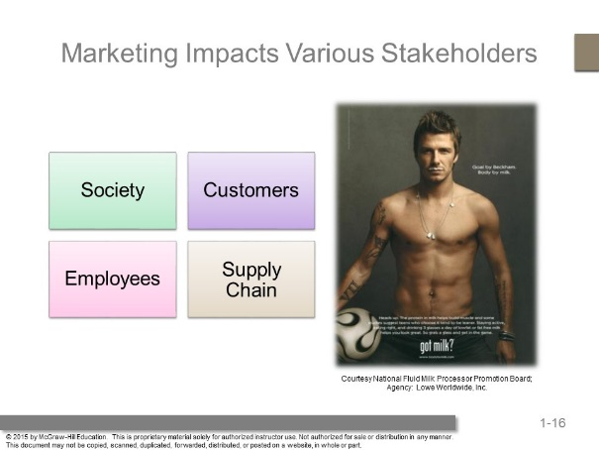 | Marketers affect many stakeholders. Customers represent one stakeholder group but others include all those in the supply chain, employees, and society at large.  Supply chain partners include manufacturers, agents, wholesalers, retailers, and so on. Companies market to employees with employment marketing, also known as internal marketing, to recruit and retain the best employees.
- Marketing Helps Create Value  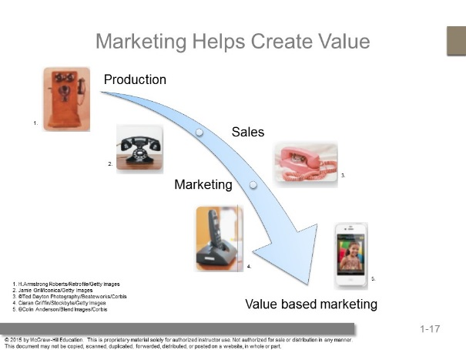 | Marketing has been through several eras. This exhibit graphically represents the changes over time from an emphasis on production to one based on value-based marketing.  The production-oriented era took place around the turn of the 20th century, when most firms believed a good product would sell itself.  In the sales-oriented era, production and distribution techniques improved and supply outpaced demand. Firms found an answer to overproduction by focusing on sales.  In the market-oriented era, the focus was on what customers wanted.  Now, we are in the value-based era, which maintains the market orientation but also includes a focus on giving greater value than the competition.  Value reflects the relationship of benefits to costs. Value-based marketing means implementing a marketing strategy according to what customers value.
- Value-Based Marketing  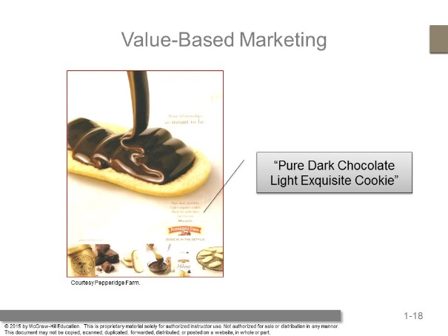 | Ask students how this campaign for Pepperidge Farm Cookies is about value. It does this by describing their ingredients in very luxurious terms…very impressive for a supermarket cookie that is not highly priced.
- Check Yourself  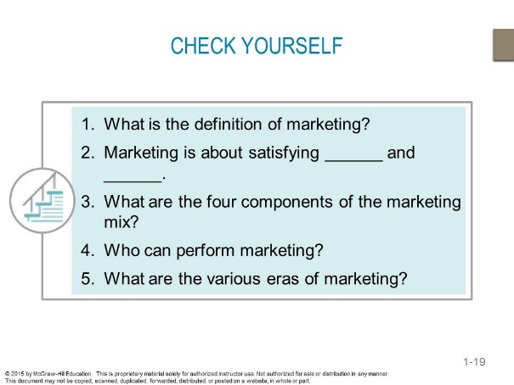 | - Marketing is an organizational function and a set of processes for creating, communicating, and delivering value to customers and for managing customer relationships in ways that benefit the organization and its stakeholders.  - Needs and wants  - Product, price, place, and promotion  - Individuals and organizations  - Production, sales, market, and value-based
- Value Based Marketing   | The Adding Value box emphasizes how value depends upon what’s important to customers.  Levi Strauss offer jeans that are affordable and stylish.
- Companies that Put the Customer First  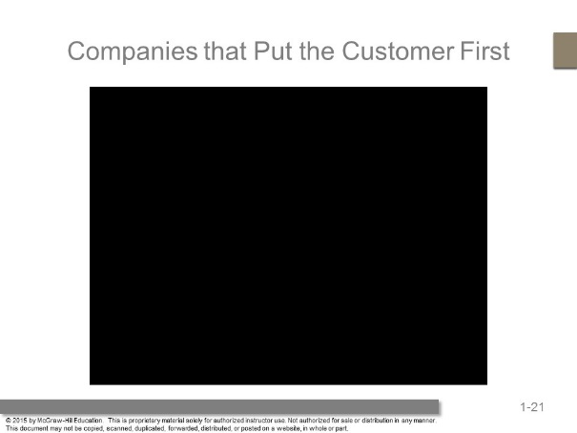 | Features the Ritz Carlton. This clip focuses on creating customer service with augmented experiences offered to the consumer.  Note: Please make sure that the video file is located in the same folder as the PowerPoint slides.
- How Do Firms Become Value Driven?  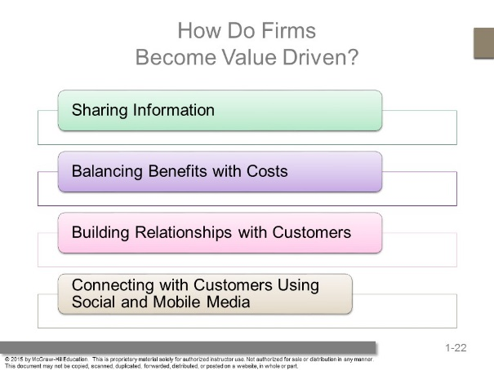 | Firms become value driven by focusing on four activities.
- Connecting With Customers  Using Social & Mobile Marketing  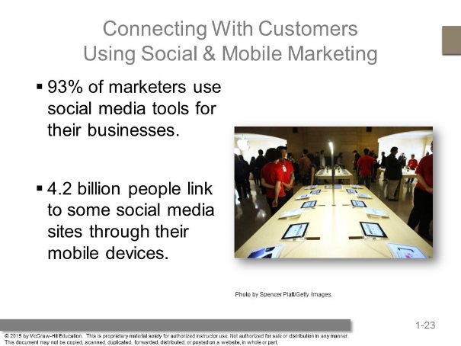 | Ask students why it is important share information using social and mobile tools?
- Check Yourself  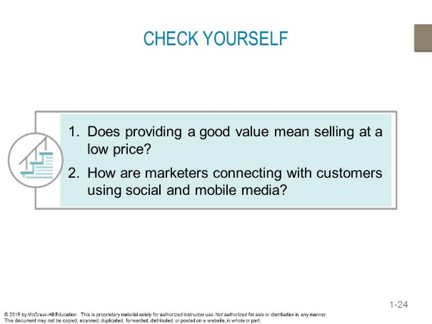 | - Value-based marketing isn’t just about low price; it is also about creating strong products and services.  - Marketers are steadily embracing new technologies, such as social and mobile media, to allow them to connect better with their customers and thereby serve their needs more effectively.
- Marketing and Society Focusing on many factors  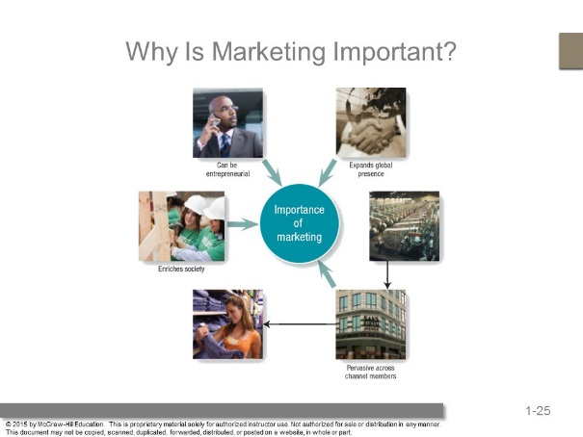 | Marketing has shifted its focus dramatically; it also has evolved into a major business function that crosses all areas of a firm or organization.
- Marketing Is Pervasive across  Marketing Channel Members  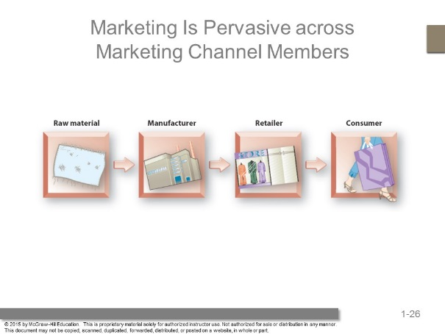 | Effectively managing supply chain relationships often has a marked impact on a firm’s ability to satisfy the consumer, which results in increased profitability for all parties.
- Marketing and Society Focusing on many factors  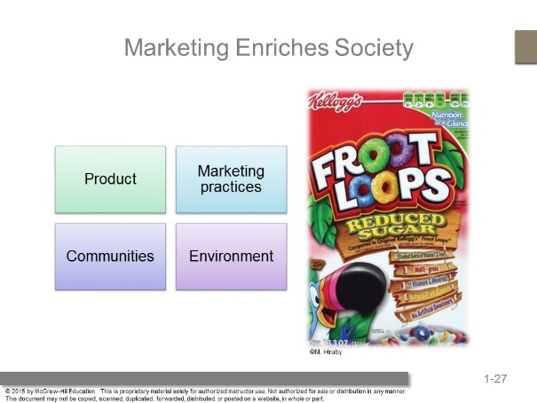 | Kellogg’s asserts:  Our values: we act with integrity and show respect.  Our foods: we produce a range of foods to meet your tastes and health needs.  Our marketing practices: long-standing commitment to responsible marketing.  In our communities: great things can happen when a company is an active corporate citizen.  Our environment: we’re helping to preserve and protect our natural resources.
- Marketing Enriches Society  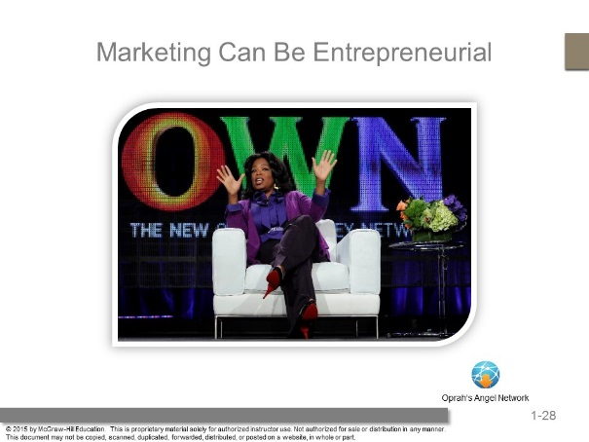 | Oprah is very entrepreneurial and an excellent marketer.  Her organizations also benefit society under the umbrella of the Oprah Winfrey Foundation.  This web link brings you to her webpage for Oprah’s Angel Network.
- Check Yourself  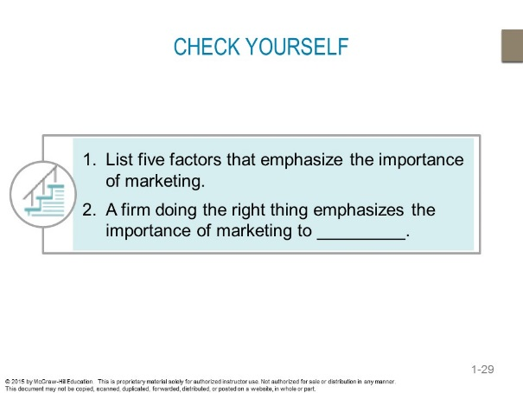 | - Expands global presence, pervasive across organization, pervasive across supply chain, makes life easier, enriches society, can be entrepreneurial.  - To do the right thing, the firm will emphasize society. This is a good time to introduce the debate of whether it is best to do right by society or right by stakeholders.

Answers To End Of Chapter Learning Aids

Marketing Applications

- Do you know the difference between needs and wants? When companies that sell frozen desserts develop their marketing strategy, do they concentrate on satisfying their customers’ needs or wants? What about a utility company, such as the local power company? A humanitarian agency, such as Doctors without Borders?

Needs are essential items that individuals cannot live without. These include necessities like shelter, health care, basic food and basic transportation. Wants are products that customers would like to have and view as improving their quality of life, like name brand clothing, computers, and luxury vehicles.

This question is intended to make students think about the difference between customer needs and wants, as well as how companies might address one or both. It also challenges students to explore whether different types of companies address the needs and wants of consumers differently. Companies that sell frozen desserts are probably concentrating on satisfying customers’ wants, as their products are considered “treats.” Firms also must respond to competitors’ offerings. An electric utility company might have a strong imperative to satisfy customers’ needs for reliable electricity but not focus as much on customer wants because it faces little market competition. Student responses should reflect an awareness of considering both consumers wants and needs. Humanitarian agencies, like Doctors without Borders, are satisfying customers’ needs, especially their basic needs for health care and medicine.

- People can apply marketing principles to finding a job. If the person looking for a job is the product, describe the other three Ps.

Students should define the remaining Ps in the marketing mix and better define the product P. In addition, answers should consider how a person seeking employment can offer value to a potential employer and how employers might add value to prospective employees. Responses should answer the following questions.

What employer needs and wants can the applicant offer to fulfill (product)?

What will it cost the potential employer to higher the applicant (price)?

How will the employer promote the job to the pool of possible applicants (promotion)?

Where and when will the job be available (place)?

- What is the difference between a good and a service? When you buy a music subscription on Pandora, are you buying a good or service? Would your answer be different if you bought an MP3 album on Amazon?

Goods are items that you can physically touch, whereas, services are intangible customer benefits that are produced by people or machines and cannot be separated from the producer.

Students should understand that in terms of the creation of each, they are both “created” using raw materials that are “processed” into a finished output.

- One of your friends was recently watching TV and saw an advertisement that she liked. She said, “Wow that was great marketing!” Was the ad in fact marketing?

Students frequently associate advertising with marketing, but fail to recognize that advertising is just one part of all the functions encompassed by marketing. Student responses should acknowledge that marketing is made up of product, price, place, and promotion decisions and advertising is one of the promotional tools available to marketers.

- Using the four Ps, discuss how the Apple iBeacon will create value for customers.

- iBeacon is software that works as a location service, such that transmitters can send messages to any user with an iPhone or iPad that has been updated to iOS 7. (product).
- iPad and iPhone owners will receive iBeacon when they freely update their systems to iOS 7 (price).
- Apple has currently chosen to not actively communicate about iBeacon to customers (promotion).
- iBeacon is electronically available over any Internet connection (place).

- Columbia Sportswear sells a men’s fleece vest for $36.00 and an Omni-Heat Jacket for $1,200. Is Columbia Sportswear providing the target markets for these products with a good value? Explain your answer.

Columbia Sportswear is pursuing a value-based marketing strategy. Value-based marketing isn’t just about low price; it is also about creating strong products and services that customers value. Each of the target markets desire different brand qualities and judge the value of these qualities differently.

- Assume you have been hired into the marketing department of a major consumer products manufacturer, such as Nike. You are having lunch with some new colleagues in other departments—finance, manufacturing, and logistics. They are arguing that the company could save millions of dollars if it just got rid of the marketing department. Develop an argument that would persuade them otherwise.

This scenario forces students to think about the purpose and value of marketing in an organizational context and allows for a variety of justifications. For example, a student could use an internal or external perspective and argue that finance, manufacturing, and logistics tend to worry less about the customer and more about internal processes, whereas the marketing and sales functions constantly focus outward on the customers the company serves. Using this argument, the student might question whether other departments are willing or prepared to take on customer relations and develop an understanding of how and why customers buy the company’s product or service. Another argument might simply demand how customers will even know about the company’s products if the marketing department doesn’t broadcast their features, benefits, and value outward.

- Why do marketers like GE find it important to embrace societal needs and ethical business practices? Provide an example of a societal need or ethical business practice that GE is addressing.

This question centers on the role of social and ethical issues in a marketing context. Students might mention efforts such as keeping the environment clean and offering fair wages to workers. For example, GE develops multiple green initiatives. Some examples:

- RAD (Responsible Appliance Disposal) Program
  - As the first and only appliance manufacturer to implement the EPA’s Responsible Appliance Disposal Program, GE is helping to reduce emissions of greenhouse gases and the amount of waste entering our landfills, protecting our air and water.
- EPA's WasteWise Program
  - GE is proud to partner with the EPA's (Environmental Protection Agency) WasteWise Program – a voluntary initiative focused on waste reduction and saving environmental resources while reducing emissions.
- EPA's SmartWay Program
  - Through a partnership with EPA's SmartWay Program, GE Appliances is also committed to more sustainable transportation when moving appliances from manufacturing operations to retailers and consumers.

Quiz Yourself

- Melanie works for a small computer software company. Her boss is constantly improving their products but neglecting customers, billing, and promoting the company. Her boss is probably stuck in the _____________ era of marketing.

A. production
B. sales
C. marketing
D. value-based marketing
E. retailing

The production era of marketing dealt primarily with manufacturing processes and the design of a good product, but without concern for meeting specific customer needs.

- In delivering value, marketing firms attempt to find the most desirable balance between:

A. the need for value and the perception of value.
B. explicit versus implicit value.
C. providing benefits to customers and keeping costs down.
D. the desire to satisfy customers and the need to keep customers from running the company.
E. the need for product improvement and the need for advertising.

The challenge for all firms is to provide the value customers expect while keeping costs low enough to allow the firm to be profitable.

Net Savvy

- Visit Apple (www.apple.com). What value does Apple provide customers? What are the advantages to using Apple to buy music or to rent/buy videos?

Most students should be familiar with Apple products and services. Students might suggest that Apple provides value because of the convenience and ease of use of its products. Apple may also provide value because of the compatibility of all of its products and services. Some of the advantages of using Apple to buy music or to rent/buy videos are the ease of use, broad selection, and newness of the music and movies.

- Go to Facebook.com and click on “About” at the bottom of the page, then click on the About tab. What is Facebook’s mission? How could a marketer use Facebook, and what other social media tools could he or she use? What are the drawbacks a marketer might face when using Facebook?

Mission: Facebook's mission is to give people the power to share and make the world more open and connected.

For the aggressive guerilla marketer, Facebook offers a variety of viral channels to get the word out and creatively reach target audiences. For marketers with a budget, Facebook offers both integrated and self-serve solutions to reach broader slices of the Facebook audience. For marketers who can harness technical resources, the Facebook Platform offers the most powerful way to create engaging connections with your target audience on Facebook.

- Visit Mondelez International’s website (www.mondelezinternational.com), then click on the “Brand Family” link. In what major categories does Mondelez have brands? Can you identify related categories in which they should compete?

Current brand categories are beverages, biscuits, cheese, grocery, chocolate, gum, and candy. Including billion dollar international brands: Cadbury chocolates and drinks, Cadbury Dairy Milk, Jacobs specialty coffees, LU biscuits, Nabisco cookies and crackers, Oreo cookies, and Trident chewing gum. Students will respond with many categories related to type of food categories.

Chapter Case Study: A Starbucks Juggernaut

- Visit the Starbucks website and list some other ways, beyond those listed in the case, that it tries to create and provide value with and for customers.

Starbucks also offers:
Bakery Products
Starbucks Petites
Bistro Boxes
Hot Breakfast
Sandwiches, Paninis & Salads
Yogurt and Fruit
La Boulange
Evolution Harvest™ Bars

- What sorts of expansions seem most likely to benefit Starbucks in the future? Which seem most risky?

One the key aspects of the expansions is control of the marketing plan. Some flexibility is required to make sure the marketing plan matches the market. In the United States, Starbucks actively avoids any franchise agreements. It wants to own all its stores, to ensure consistency and quality. Based on this, those markets where Starbucks has to relinquish much control are the riskiest propositions (i.e., India and China).

- How can Starbucks ensure that it continues to meet customers’ expectations and needs? List some specific ways.

The key for Starbucks will be to continually keep in contact with its customers. This contact will provide valuable information that will help them make product, place, price, and promotion decisions. For example, Starbucks can implement thinks like focus groups, in-depth interviews, and surveys. Students will learn in later chapters how firms conduct market research.

- Visit the Starbucks website and identify its latest promotion. How does this promotion help create value for the customer, and ultimately, Starbucks?

Recently the company was promoting its loyalty program – “My Starbucks Rewards.” It is offering: “Register a Starbucks card to join My Starbucks Rewards and sign up to receive email rewards, and you’ll get a free drink.”

This promotional gives customers the value of price discounts, directed marketing communication, and better customer service. Loyalty programs provide value to Starbucks by retaining existing customers, acquiring new customers, and increasing customer lifetime value.

- Why can Starbucks charge so much for a latte when they are less expensive at chains like Dunkin’ Donuts?

Starbucks is offering more than customers expect for retailers like Dunkin’ Donuts. It atmosphere, prestige, and quality are all things that allow it to charge a premium for its products. Students will learn in later chapters how firms determine price.

Additional Teaching Tips

In this chapter, the goal is to provide an overview of marketing and encourage students to think about the specific aspects of the marketing mix.

Place is one of the most difficult concepts for students because it is largely invisible to them as consumers. They touch hard goods, experience services, view and hear promotions, and pay for what they buy, but it can seem that products almost appear magically. One recent trend among environmentally-conscious consumers is to seek out products produced within a 100-mile radius of their home towns. Buying these products reduces costs and detrimental environmental effects by reducing emissions associated with transportation and storage. Students should visit local grocery markets, identify goods, and investigate how far the products traveled (and by what means) to reach the store’s shelves. From this experience, a rich discussion of both distribution decisions and marketing’s impact on society can evolve.

To make the eras of marketing clear to students, divide the class into groups with each group assigned to a specific era. Ask the students to identify a business that adheres to their assigned era in terms of its business philosophy and approach. They should present the business to the class with evidence of the business’s philosophy. Each brief presentation should include an assessment of whether the orientation is appropriate to the business given its competitive environment, target audience, and positioning strategy and if not, what orientation would be best.

Remember to review the Newsletter for Instructors and its accompanied PowerPoint presentation, which integrates examples and discussion from the newsletter. Each newsletter contains over ten article abstracts on hot topics, plus a selection of current commercials and videos for you to use with your class. The newsletter also includes a guide that explains where the articles, commercials, and videos best fit in your Marketing course.

